Overview:
The MARI LoRa Monitor is the Ground Control Station (GCS) and diagnostic suite designed for the MARI Drone. It bridges the gap between low-level serial communication and high-level telemetry visualization. It is meant to take and parse data from the LoRa UART for RYLR998 module.

What you are looking at:
At the very top of the application, visible regardless of which tab you are in, is the Global Ping Banner or MARI STATUS
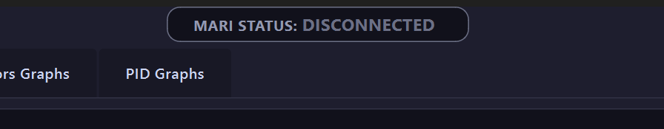
This displays whether the system is DISCONNECTED, WAITING for a response, or CONNECTED. When connected, it shows the RTT (Round Trip Time) in milliseconds, allowing you to gauge signal lag instantly.

Warning: ALL incoming data will be blocked until a successful ping connection is established to ensure you only see valid telemetry. Write ‘ping’ to override it.

Next you will see the Console.
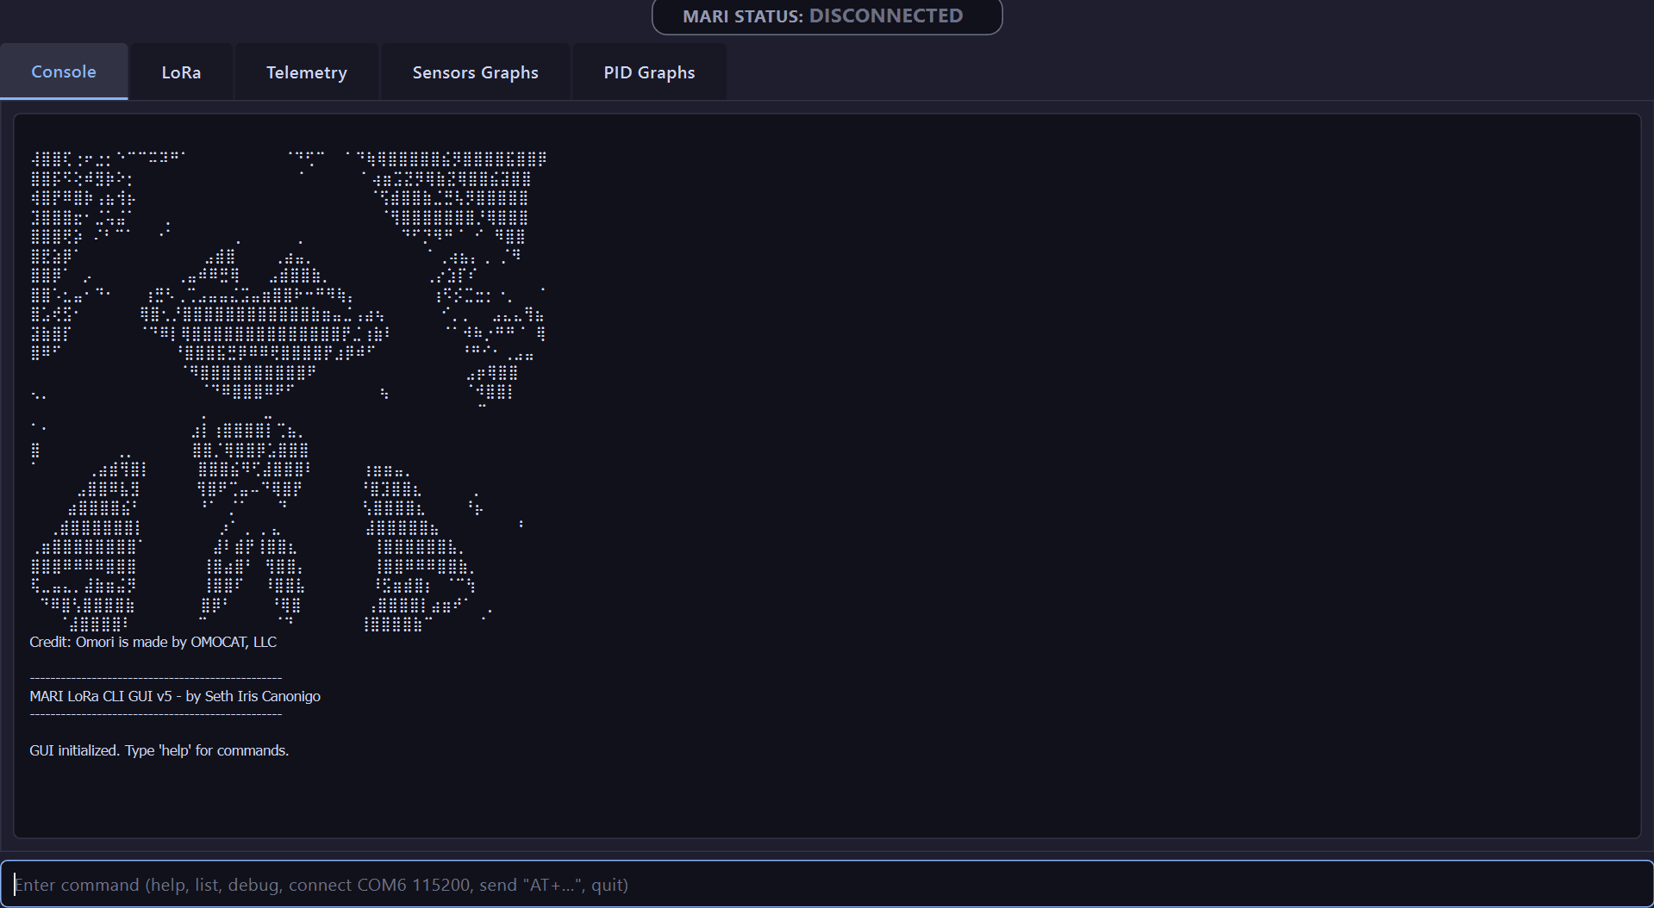

This is your primary interaction log. It shows every command sent and every raw message received. All displays are disabled by default. Type the command display to enable.

The next tab is LoRa. Here you can see many metrics.

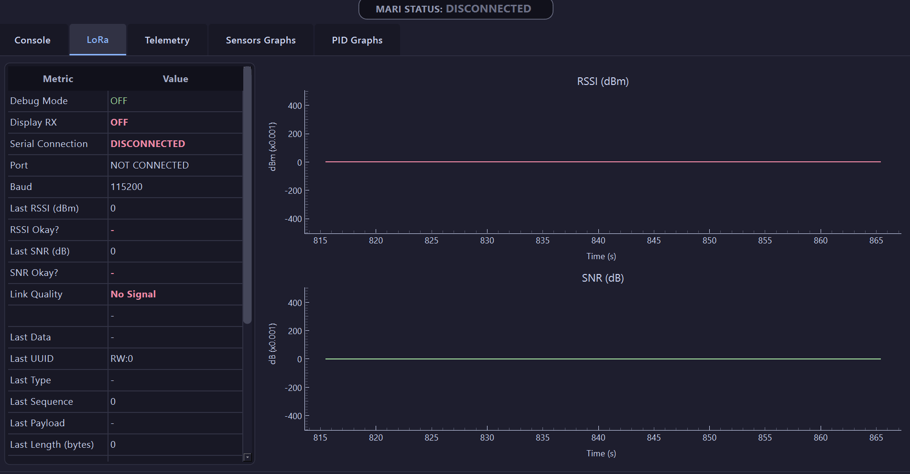

The next tab is Telemetry. Here you can see the parsed useful values in each packet sent.

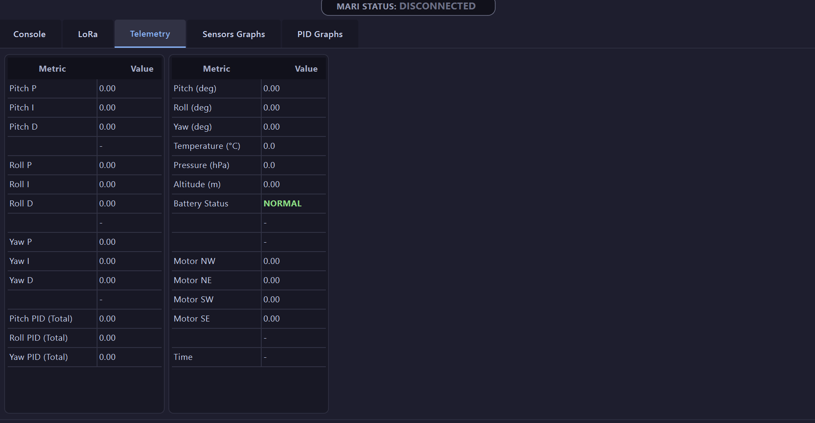

The next tab is Sensors Graphs. Here you can see the graphed IMU measurements of pitch, roll, and yaw in real-time as well as the four PWMs being outputted.

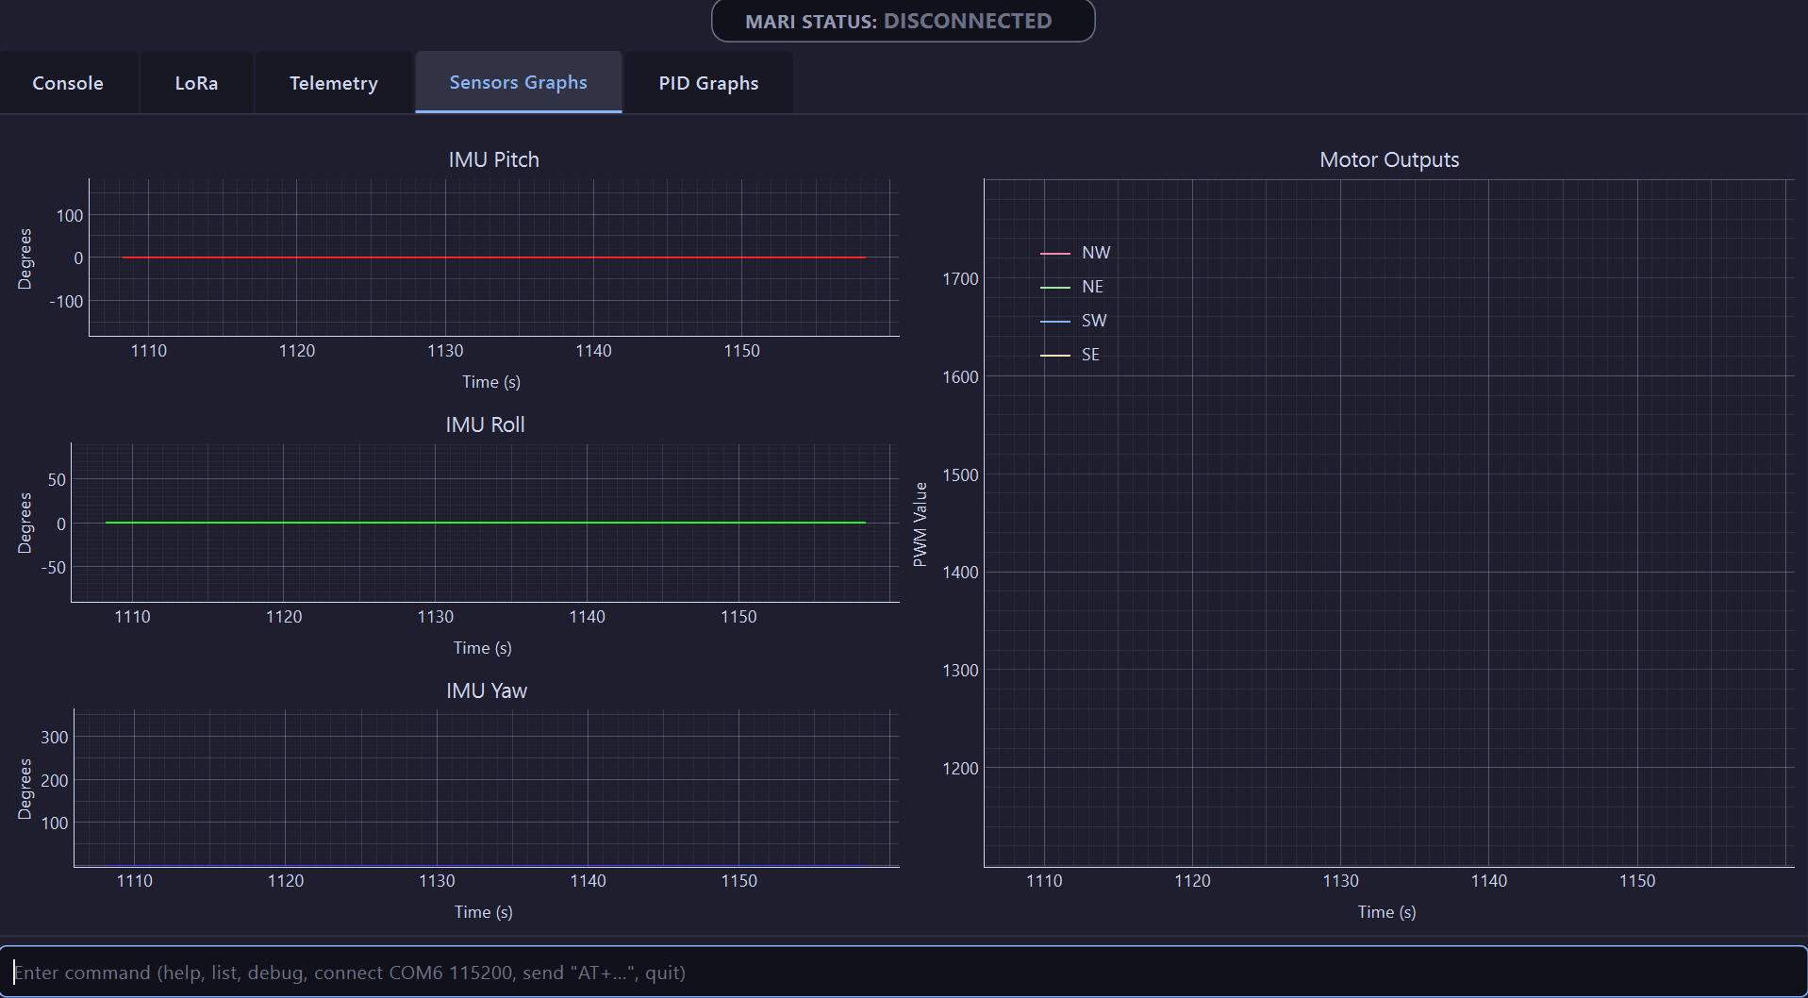

The next tab is PID Graphs. Here you can see each component for Pitch, Roll, and Yaw as well as the totals of all three.

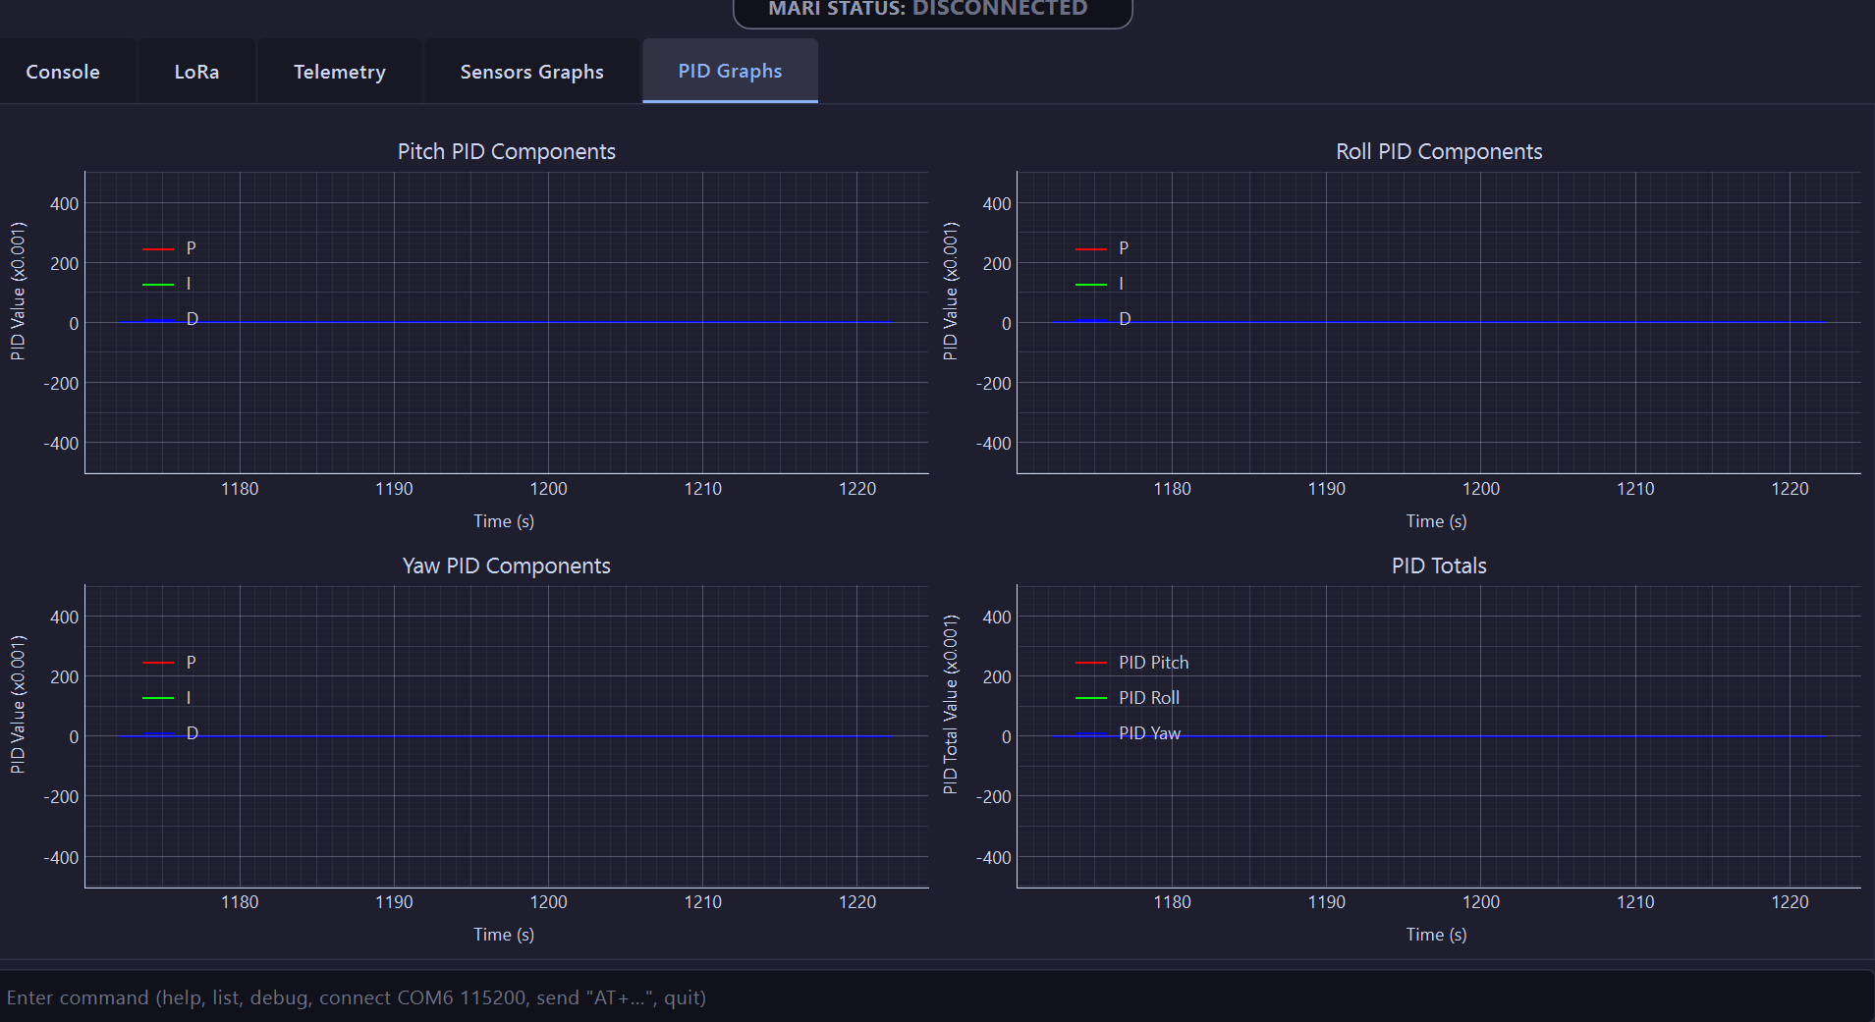

List of commands:

help [topic] - show help for commands or specific topic
connect [PORT] [BAUD] - connect to serial port
disconnect - disconnect serial port
list - list available serial ports
art - show Mari ASCII art in console
raw on|off - toggle raw RX output
log [path]|off - enable/disable logging of raw lines to a text file
plog [path]|off - enable/disable logging of parsed drone status to a csv file
ping - Send SUNNY ping with a fixed 88-byte payload to current target address (requires serial connection)
test - send a simple AT command to test connectivity (requires serial connection)
reset - send AT+RESET to the LoRa module (requires serial connection)
send "AT+..." - send a custom AT command to the LoRa module (requires serial connection)
clear - clear the console log output, graphs, and reset drone status
target <addr> - set target address for MARI commands (requires serial connection)
stopwatch start|stop|reset - control a stopwatch timer in the GUI
mari <cmd> - send a MARI system command (e.g. mari sunny 1) (requires serial connection)
mari [sunny|ping] [1|2|3|4] - send a SUNNY command with increasing payload sizes for testing (requires serial connection)
mari oyasumi - send a MARI "good night" command (requires serial connection)
mari ohayo - send a MARI "good morning" command with setup sequence (requires serial connection)
mari override - manually set MARI ping state to CONNECTED (for testing) (requires serial connection)

How to use MARI LoRa Monitor:

Prerequisite:
- Check if Windows USB-to-UART bridge drivers are installed in Device Manager
- Turn OFF Real-time Protection in Windows Security and other antivirus software

Connect to Serial Comm via USB-UART:
- Type ‘list’ to show available serial com ports
- Type ‘connect [COM PORT]’ to connect to the serial port

Connect to display:
- Type ‘display’ to enable Display RX which enables the console to log

Override SUNNY
- Type ‘mari override’

How to export values to csv
- Type ‘plog’

How to get raw console logs
- Type ‘log’

